Hands-On Lab Report: SQL Injection on DVWA
Objective
To understand how SQL Injection works by testing a deliberately vulnerable application (DVWA) in a controlled lab environment and observing how improper input validation leads to authentication bypass.
What is DVWA?
DVWA (Damn Vulnerable Web Application) is a deliberately insecure web application designed for learning and practicing web security in a safe, controlled environment.
DVWA is a practice lab for hackers and security learners where you can safely test vulnerabilities like:
- SQL Injection
- Cross-Site Scripting (XSS)
- File Upload flaws
- Brute Force attacks
Step-by-Step Setup
1. Update your system
Open terminal and run:
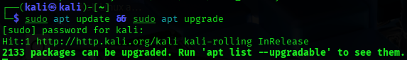
2. Install required services
DVWA needs a web server + database:
3. Start services

4. Download DVWA
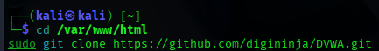
5. Set permissions

6. Configure DVWA

7. Configure database
Open: sudo nano config.inc.php
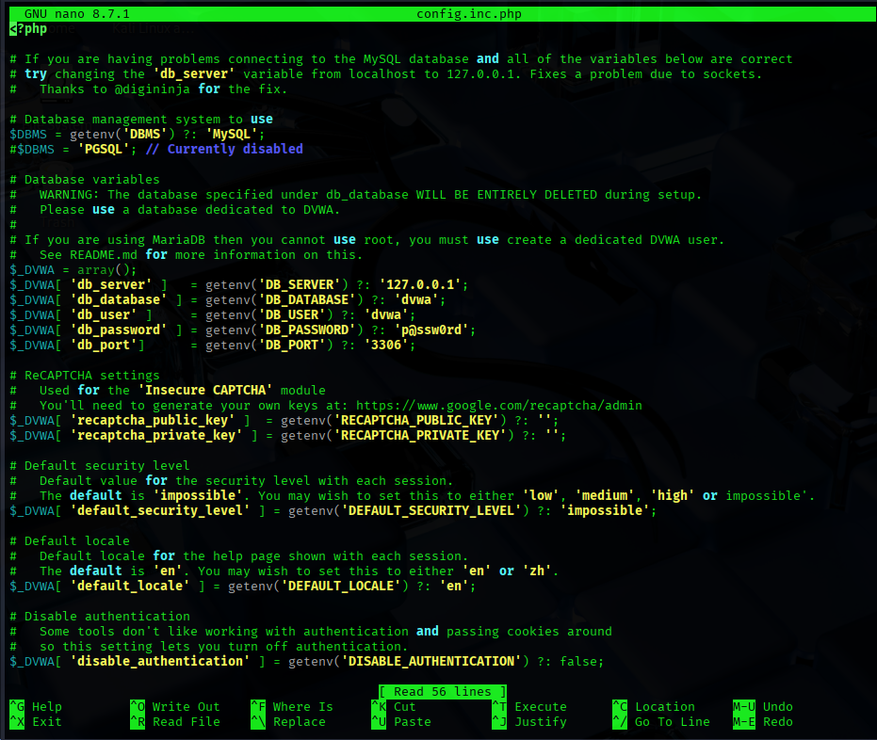
Set :
$_DVWA['db_user'] = 'root';
$_DVWA['db_password'] = 'dvwa';
8. Open in browser
Go to: http://localhost/DVWA
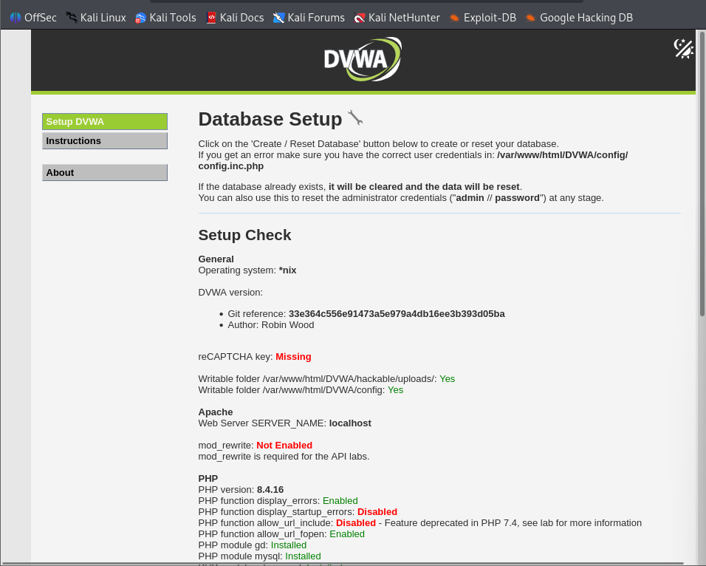
9. Create / Reset Database
Then :
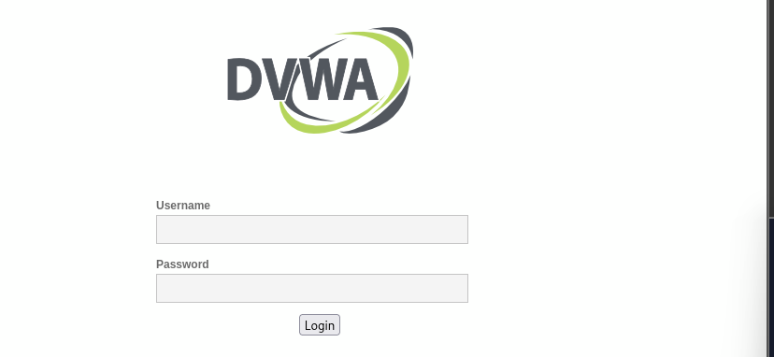
Use:
- Username: admin
- Password: password
Then the dashboard will appear:
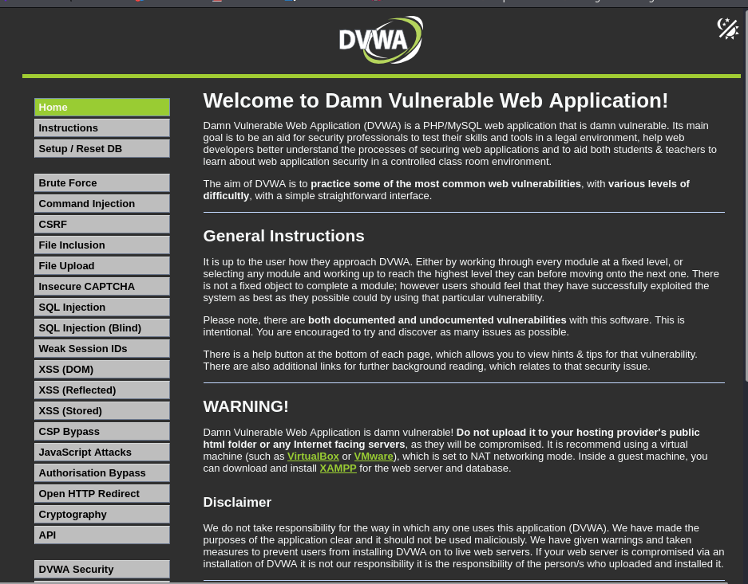
1.Set Security Level to Low
- Navigate to DVWA Security
- Set level to Low
- Save settings
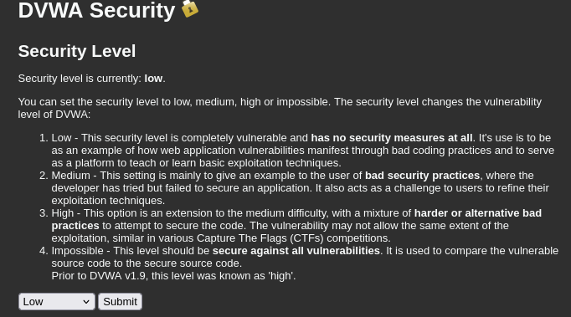
2. Understanding the Vulnerability
At low security:
- User input is not sanitized
- SQL queries are built directly using input
4. Testing for SQL Injection (Conceptual Steps)
- Enter crafted input in login form
User ID: 5
- Observe and result of the SQL injection is appear in below.
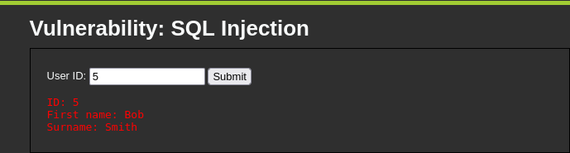
5. Impact of SQL Injection
- Authentication bypass
- Data leakage
- Database manipulation
- Full system compromise (in severe cases)

6. Mitigation Techniques
To prevent SQL Injection:
- Use prepared statements (parameterized queries)
- Validate and sanitize user input
- Use ORM frameworks
- Apply least privilege principle
- Enable Web Application Firewall (WAF)

7. Conclusion
This lab demonstrates that:
- Poor input validation leads to critical vulnerabilities
- SQL Injection is simple but highly dangerous
- Secure coding practices are essential for web security

